# **CODE AND OUTPUTS :** IMPLEMENTATION OF STAR SCHEMA

* DIMENSION TABLES

**SPECTATOR Table**

CREATE TABLE spectators (

spec_id INT PRIMARY KEY,

spec_name VARCHAR(30),

category VARCHAR(15));

INSERT INTO spectator VALUES

(101, 'EksheEk', 'senior'),

(102, 'EksheDon', 'student'),

(103, 'EksheTeen', 'adult'),

(104, 'EksheChaar', 'adult'),

(105, 'EkshePaach', 'adult'),

(106, 'EksheSaha', 'senior'),

(107, 'EksheSaat', 'student');

SELECT * FROM spectator;

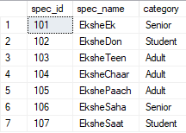

**LOCATION Table**

CREATE TABLE location(

loc_id INT PRIMARY KEY,

stadium VARCHAR(50),

city VARCHAR(15),

states VARCHAR(15));

INSERT INTO location VALUES

(1,'Narendra Modi Stadium','Ahmedabad','Gujarat'),

(2,'Eden Gardens','Kolkata','West Bengal'),

(3,'DY Patil Stadium','Navi Mumbai','Maharashtra'),

(4,'Arun Jaitley Stadium','Delhi','Delhi NCR'),

(5,'KIIT Stadium','Bhubaneswar','Odisha');

SELECT * FROM location;

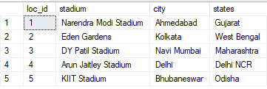

**MATCH Table**

CREATE TABLE games(

game_id INT PRIMARY KEY,

game_name VARCHAR(15),

game_type VARCHAR(15)

);

INSERT INTO games VALUES

(1,'cricket','outdoor'),

(2,'boxcricket','indoor'),

(3,'basketball','outdoor'),

(4,'football','outdoor'),

(5,'tabletennis','indoor');

SELECT * FROM games;

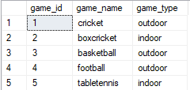

**g_dates Table**

CREATE TABLE g_dates (

g_date_id INT PRIMARY KEY,

day VARCHAR(15),

month VARCHAR(15),

year VARCHAR(4));

INSERT INTO g_dates VALUES

(1,'2','feb','2004'),

(2,'5','march','2004'),

(3,'12','jan','2005'),

(4,'20','may','2006'),

(5,'6','july','2010');

SELECT * from g_dates;

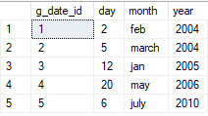

----------------------------------------------------------

* **FACT TABLE**

**game_stats TABLE**

CREATE TABLE game_stats (

spec_id INT REFERENCES spectator(spec_id),

loc_id INT REFERENCES location(loc_id),

game_id INT REFERENCES games(game_id),

g_date_id INT REFERENCES g_dates(g_date_Id),

charge int

);

INSERT INTO game_stats VALUES

(101,2,3,4,500),

(102,2,3,4,600),

(102,3,1,3,700),

(103,1,2,1,300),

(104,4,4,2,5000),

(105,1,2,4,1000),

(106,4,5,1,2000),

(107,5,1,5,800);

SELECT * from game_stats;

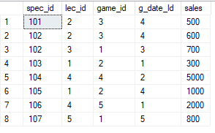

----------------------------------------------------------

QUERY ON STAR SCHEMA:

select sum(gs.charge),spec.category,l.stadium,d.year

from game_stats gs,spectator spec,location l,g_dates d

where gs.spec_id=spec.spec_id and

gs.g_date_id= d.g_date_id and

gs.g_date_id = d.g_date_id

group by spec.category,l.stadium,d.year

having spec.category='adult' and

d.year='2004' and

l.stadium='KIIT Stadium';



IMPLEMENTATION OF ETL:

**EXTRACTION**

SALEST TABLE :

create table salest(

s_person varchar(15),

item_sold int,

price int,

s_dt date,

item_category varchar(15),

num_item_sold int

);

INSERTING VALUES INTO SALEST :

insert into salest values('Mayuri','2','12000','1-feb-2012','hardware','5');

insert into salest values('Chandrika','1','1500','3-feb-2012','software','3');

insert into salest values('Shruti','2','15000','3-feb-2012','hardware','4');

insert into salest values('Akshiti','1','8000','5-feb-2012','software','7');

insert into salest values('Harshita','3','2000','7-feb-2012','software','2');

insert into salest values('Yash','2','1000','7-feb-2012','software','13');

insert into salest values('Kshitij','1','7500','8-feb-2012','hardware','10');

select * from salest;

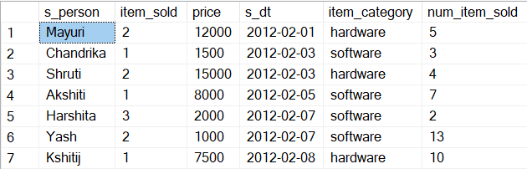

SALES_DETAILS TABLE :

create table sales_details(

sales_person varchar(30),

item_name varchar(30),

item_price int,

sales_date date,

branch varchar(30),

no_of_item_sold int

);

INSERTING VALUES INTO SALES_DETAILS :

insert into sales_details values('Mayuri','HardDisk',12000,'1-feb-2012','Thane',2);

insert into sales_details values('Shruti','CPU',15000,'3-feb-2012','Andheri',2);

insert into sales_details values('Akshiti','AntiVirus',8000,'5-feb-2012','Palava',1);

insert into sales_details values('Harshita','AntiVirus',2000,'7-feb-2012','Vashi',3);

insert into sales_details values('Yash','AntiVirus',1000,'7-feb-2012','CST',2);

insert into sales_details values('Kshitij','RAM',7500,'8-feb-2012','Thane',1);

select * from sales_details;

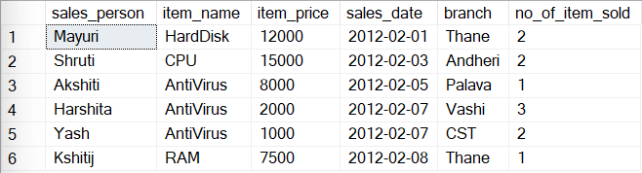

SALES_RECORDS TABLE :

create table sales_records(

supplier varchar(15),

item_name varchar(15),

price int,

sales_dt date,

branch varchar(15),

item_category varchar(15),

num_item_sold int

);

INSERTING VALUES INTO SALES_RECORDS :

insert into sales_records(supplier,item_name,price,sales_dt,branch,item_category,num_item_sold)

select s_person,item_category,price,s_dt,null,item_category,num_item_sold

from salest;

select * from sales_records;

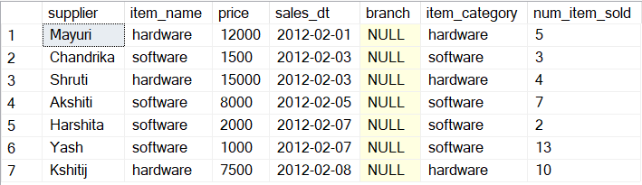

insert into sales_records(supplier,item_name,price,sales_dt,branch,item_category,num_item_sold)

select sales_person,item_name,item_price,sales_date,branch,null,no_of_item_sold

from sales_details;

select * from sales_records;

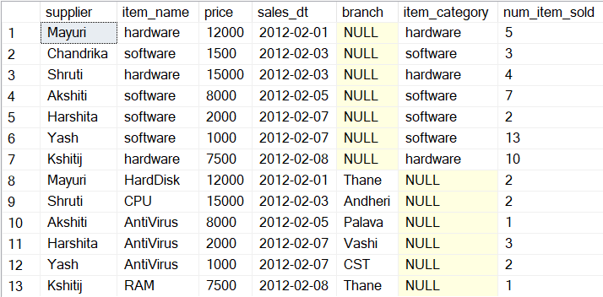

**TRANSFORMATION :**

INSERTING VALUES INTO SALES_DETAILS :

insert into sales_details

values('Om','HardDisk',5000,to_date('2012-jan-03','yyyy-mm-dd'),'Mumbai',2);

select * from sales_details;

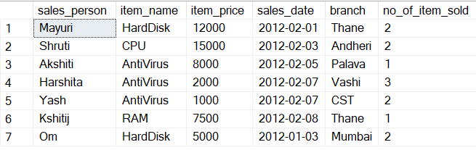

UPDATING VALUES OF SALES_RECORDS :

update sales_records set branch='unknown' where branch is null;

select * from sales_records;

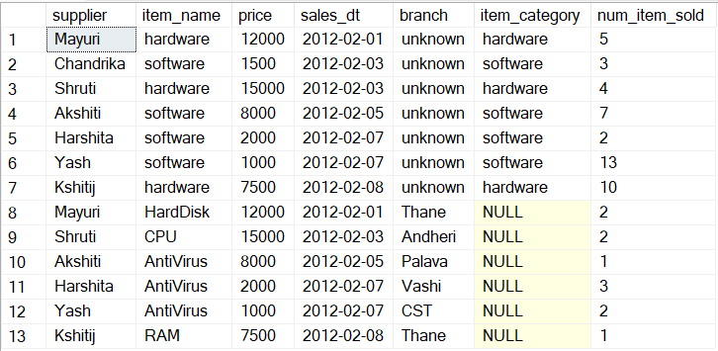

update sales_records set item_category='software' where item_name='AntiVirus';

update sales_records set item_category='hardware'

where item_name in('CPU','RAM','HardDisk');

select * from sales_records;

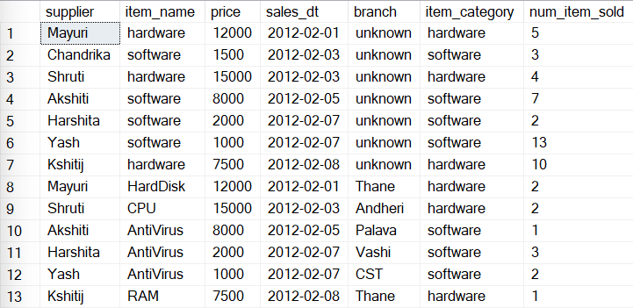

update sales_records

set num_item_sold=(select avg(num_item_sold) from sales_records)

where item_name='AntiVirus'

;

select * from sales_records;

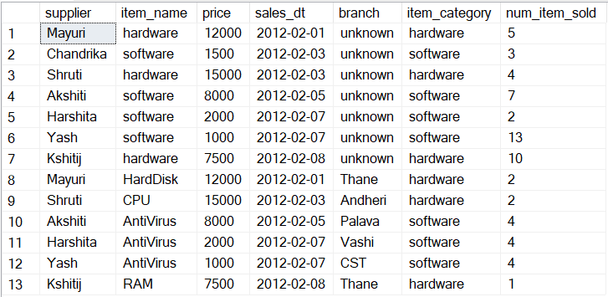

update sales_records

set num_item_sold=(select avg(num_item_sold)from sales_records)

where item_name in('CPU','RAM','HardDisk')

;

select * from sales_records;

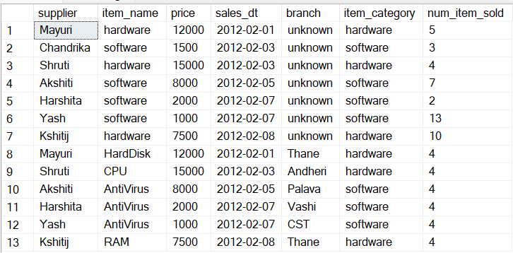

**LOADING**

CREATING VIEW CATALOG1 :

create view catalog1

as

select sum(price*num_item_sold) as yearly_sale,

sales_dt as year

from sales_records

group by sales_dt;

select * from catalog1;

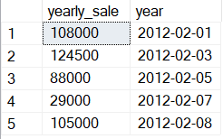

CREATING VIEW CATALOG2 :

create view catalog2

as

select sum(price*num_item_sold) as yearly_sale,

sales_dt as year from sales_records group by sales_dt;

select * from catalog2;

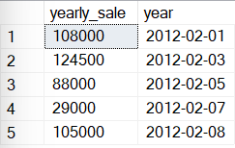

CREATING VIEW CATEGORY:

create view category

as

select * from sales_records

where item_category='software';

select * from category;



